End User Guide
For

Drilling Data Management System (DDMS)

DIRECTORATE GENERAL OF HYDROCABONS

TABLE OF CONTENTS

How to access Drilling Data Management System.………..………………………………………….……..3
1. Registration of New User………………………………...……….………………………………………………..4
2. Login Process……………………………………………………………………………………………………………6
3. Forgot Password……………………………………….……….………………………………………………………7
4. My Profile………………………………………………………….……………………………………………………..8
5. Drilling Data Entry….…………….……………….…….……..…………………………………………..………10

How to access Drilling Data Management System
- Open up www.dghindia.gov.in
- Go to Online Web Applications > Drilling Data Management System(DDMS)
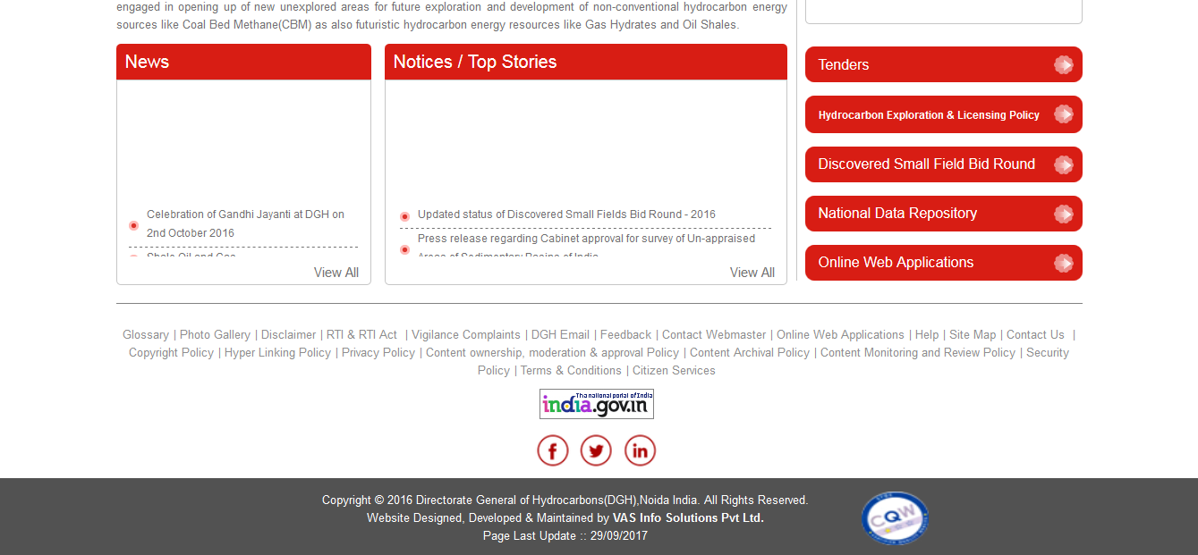
Online Web Application
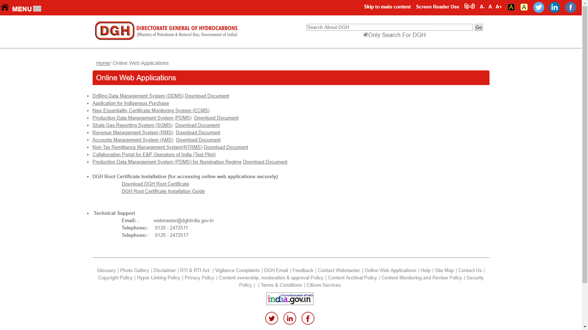
- Follow the instruction given on that page for DGH Root Certificate installation.
- Access the application on the link given on that page.
- Alternatively you can access the page directly by typing the following address on your browser (Google Chrome/Mozilla Firefox).
(https://182.19.5.116/OnlineDrilling)

- Registration of New User

For registration of new user, click on “Apply for an Account?” link on Login page.
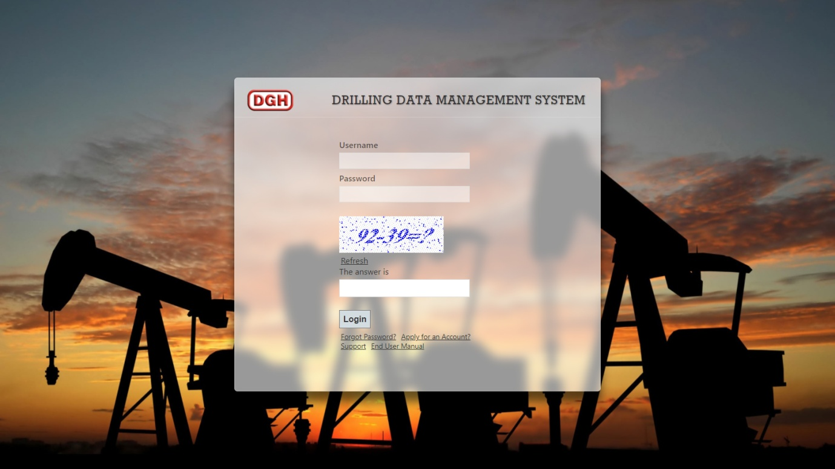

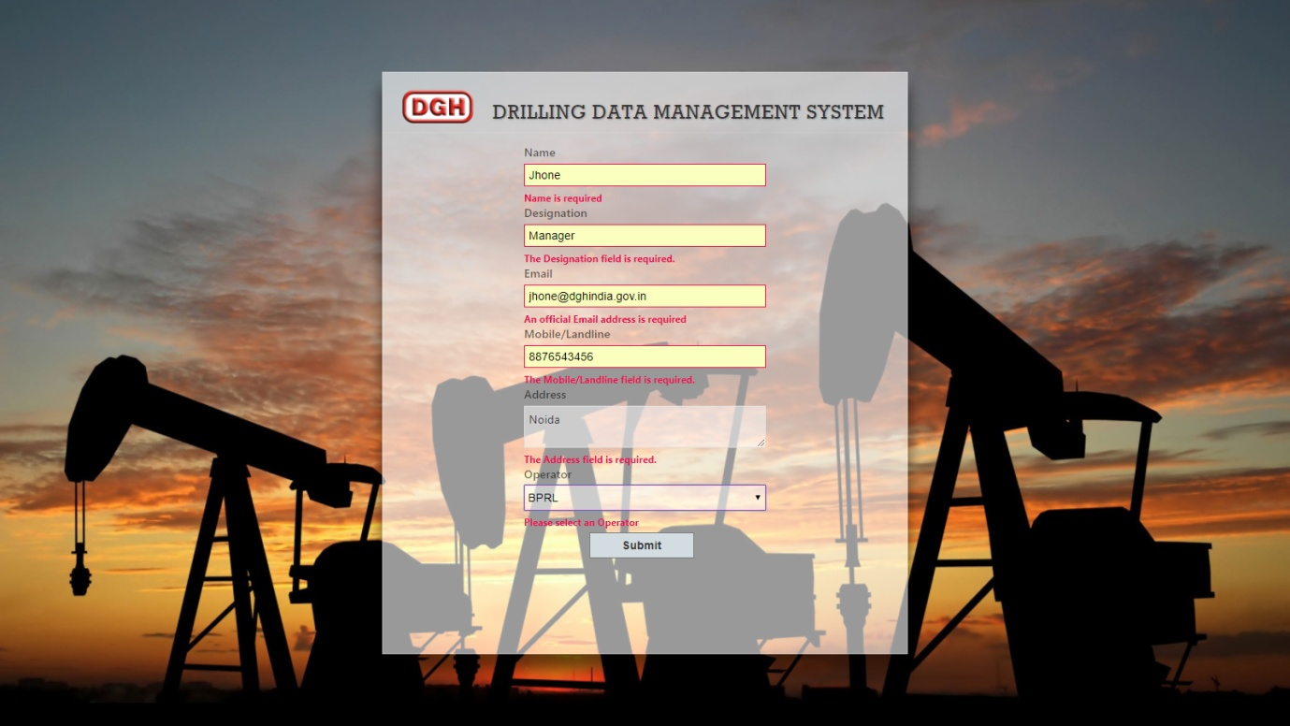
Fill user details, then click on “Submit” button.
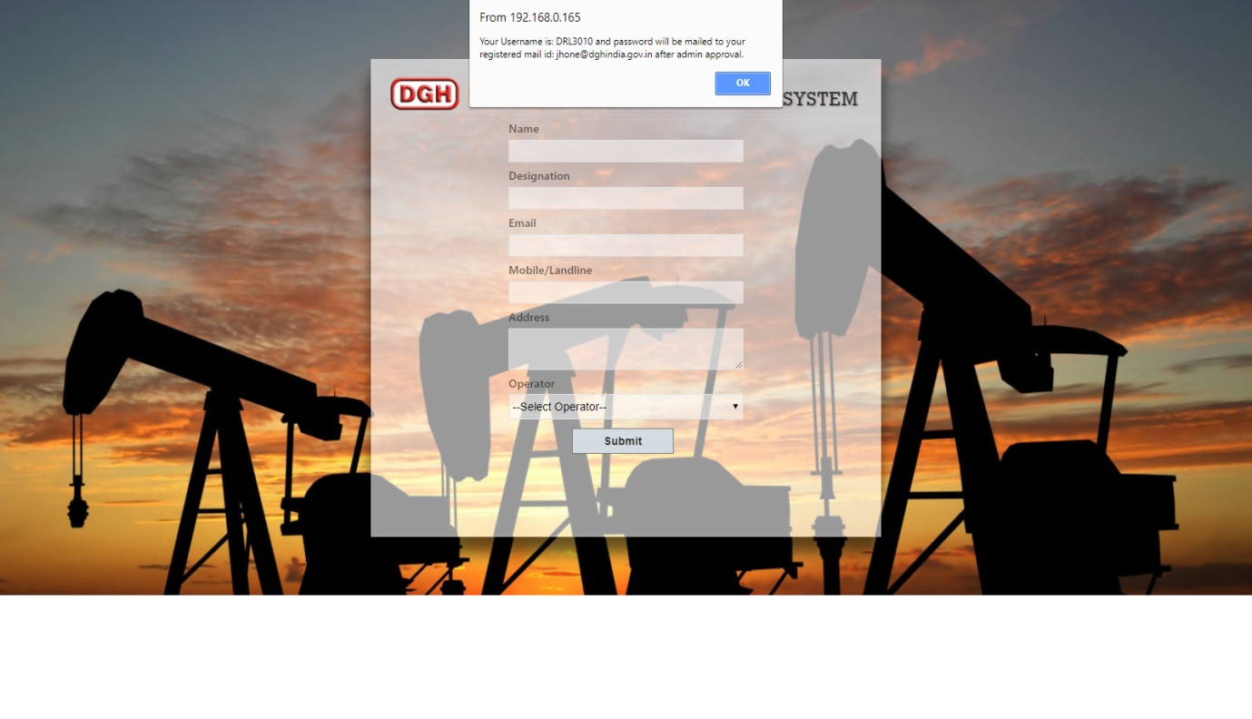
After clicking on submit you will get an message regarding username. But Password will be generated after approval by DGH. Once your application is approved at DGH, your password will be sent to your registered email id.

- Login Process

The action of providing the proper credentials for a website is called logging in, or signing in.
As a user, you are required to enter your User Name , Password and Captcha and then click on the Login button to login into the system. You will find your User Name and Password in your email inbox once you have been provided by DGH.
After logging in, it is recommended that you change your password by going to your Profile and clicking on Change Password.

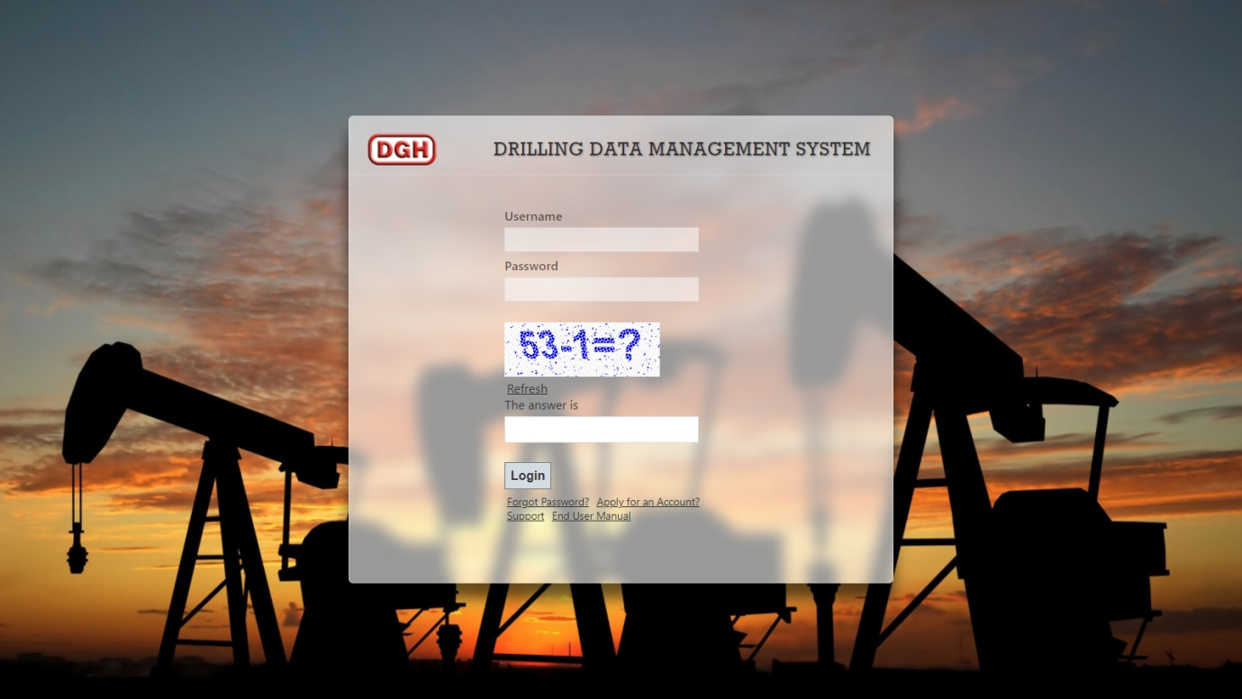

- Forgot Password

The user can use “Forgot Password?” link to reset password when user forget the password.
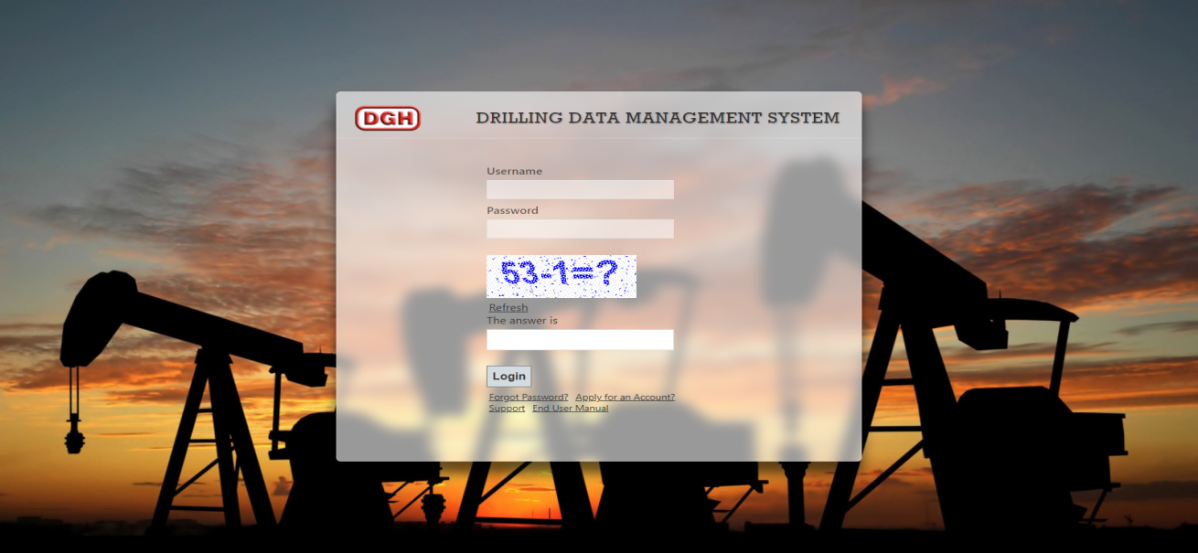

The user has to provide User Name and Email, and using captcha, New Password will be sent to email.
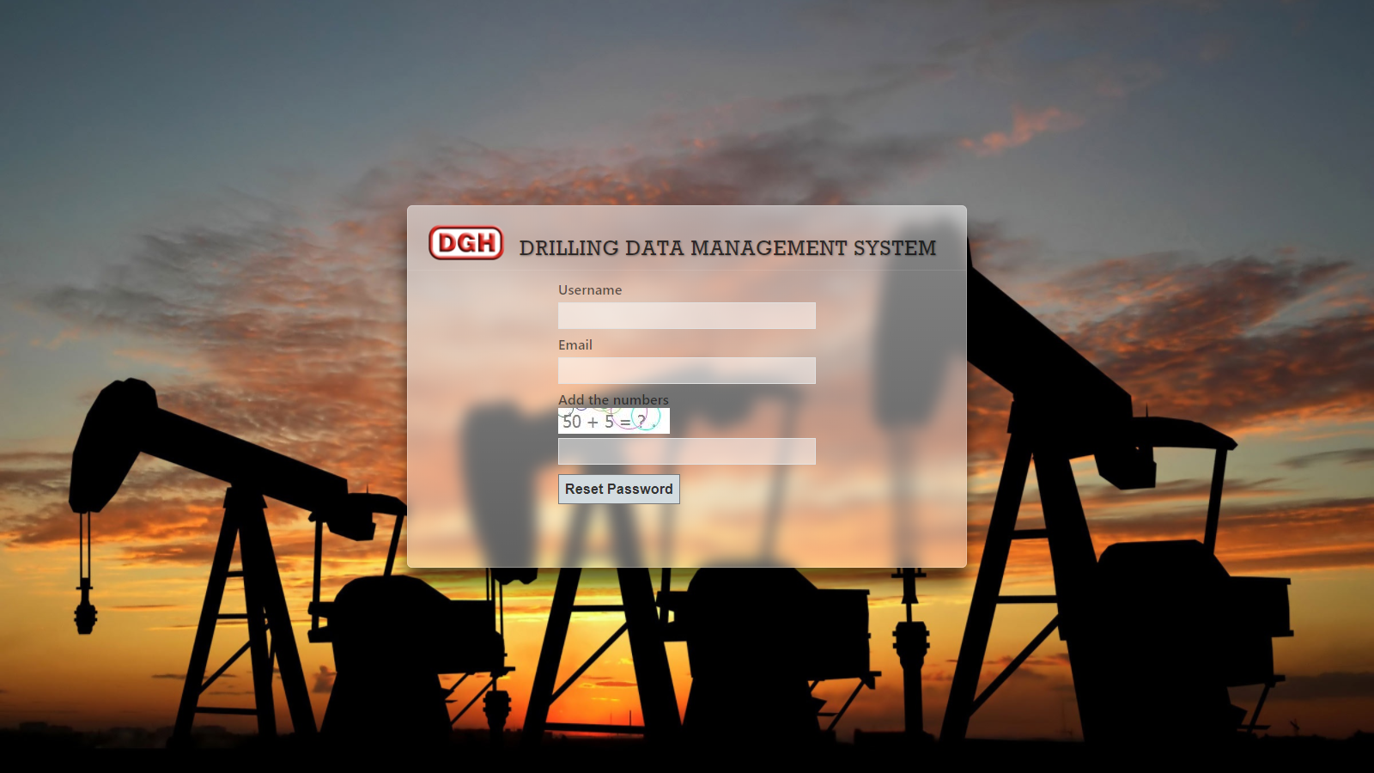

- My Profile
The user can view their user information and reset their password by going to “Profile” after login.
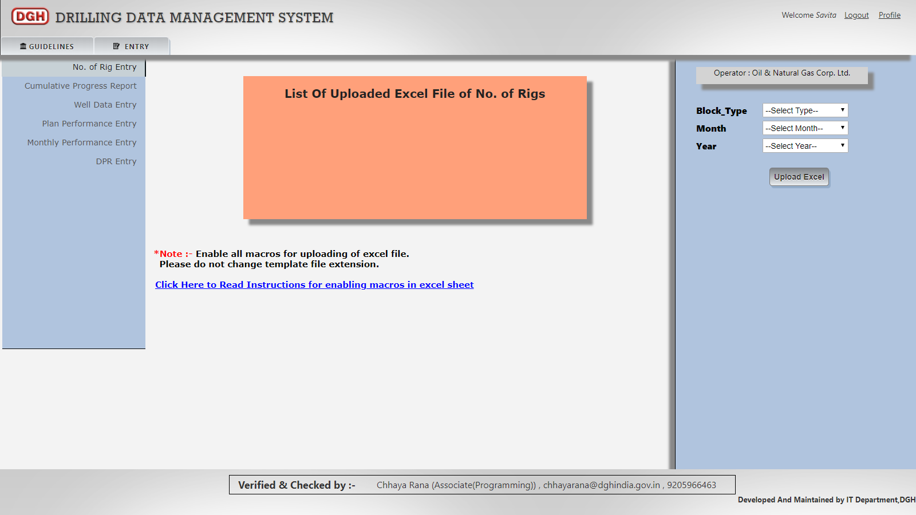

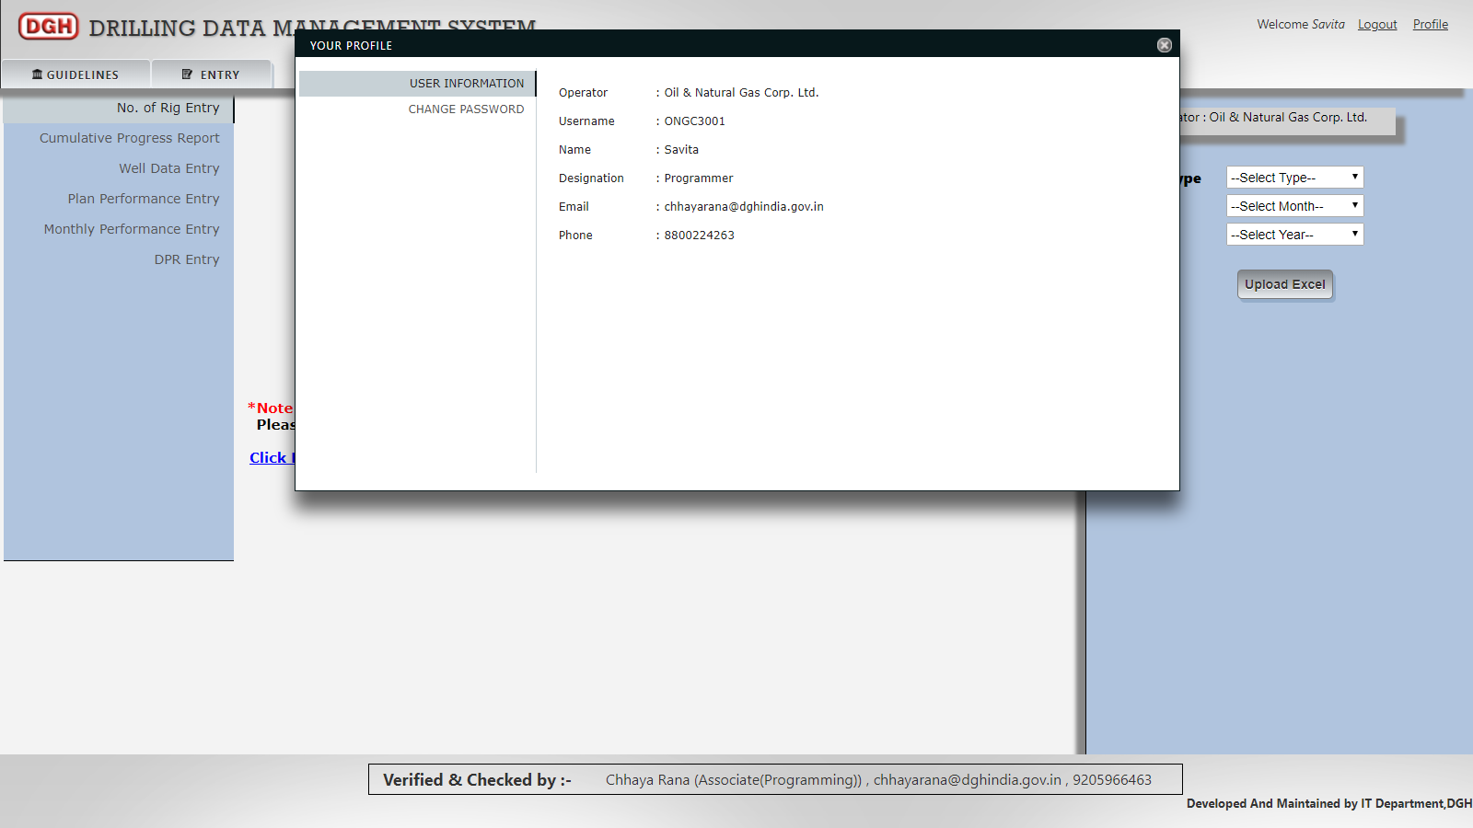

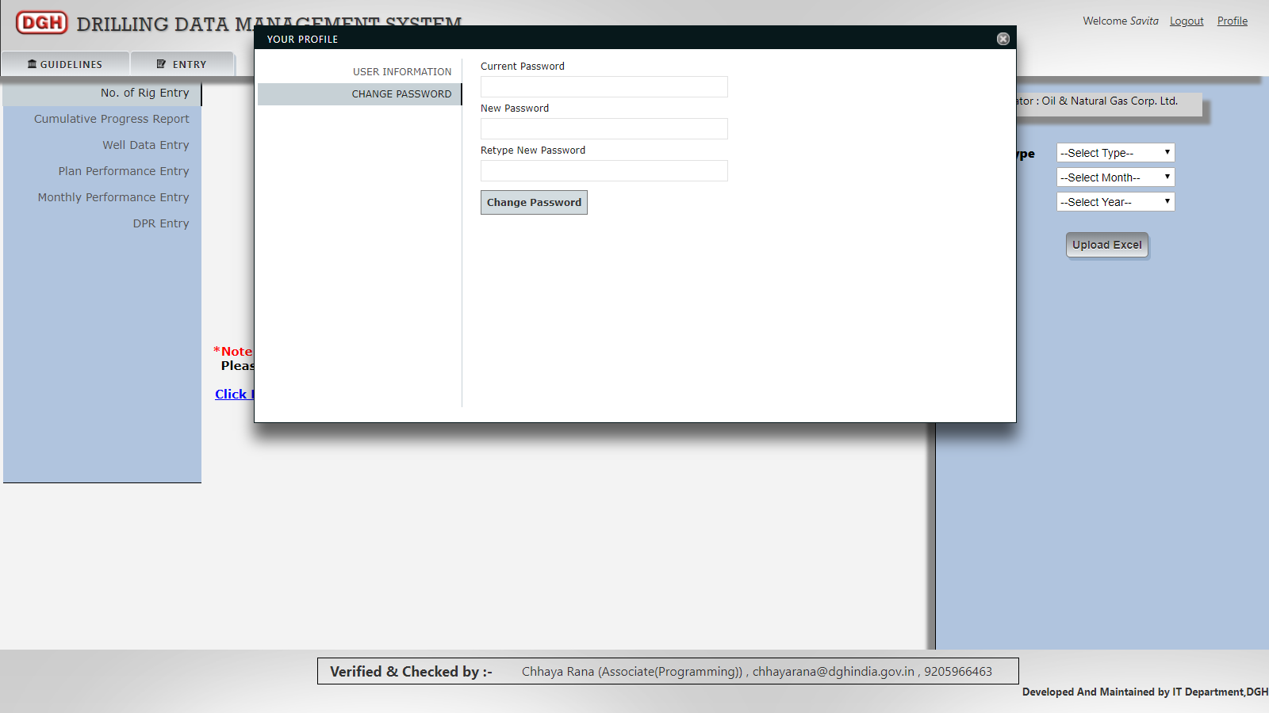

5. Drilling Data Entry
The Drilling Data Entry may be accessed by going to Entry
For uploading drilling data, user has to download excel template.
For downloading excel template, user must select Block type, month and year then click on “Upload Excel” button. After clicking on “Upload Excel” button, a dialog box will appear. User can download excel template by clicking on “Download Template”.
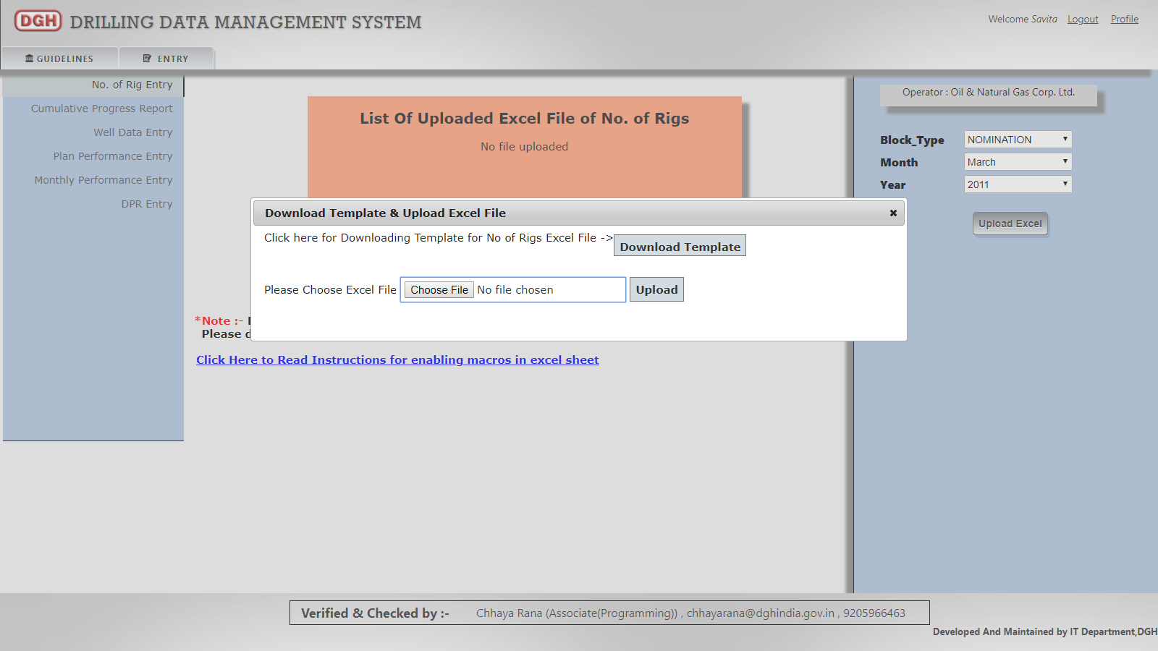

Instructions for uploading excel is provided by given link “Click here to Read Instructions for enabling macros in excel sheet”.
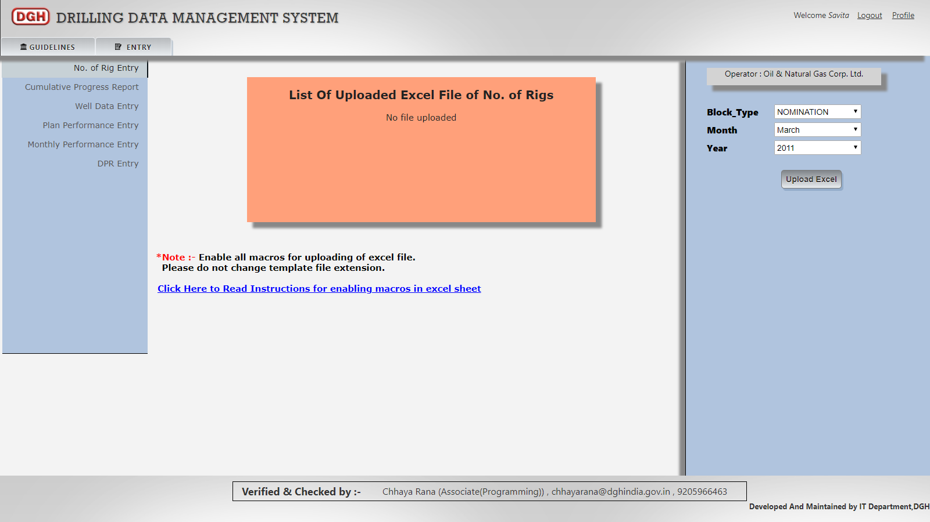
After downloading excel template and entering data in downloaded excel template, browse that excel using “Choose File” button and upload that excel by clicking on “Upload” button.
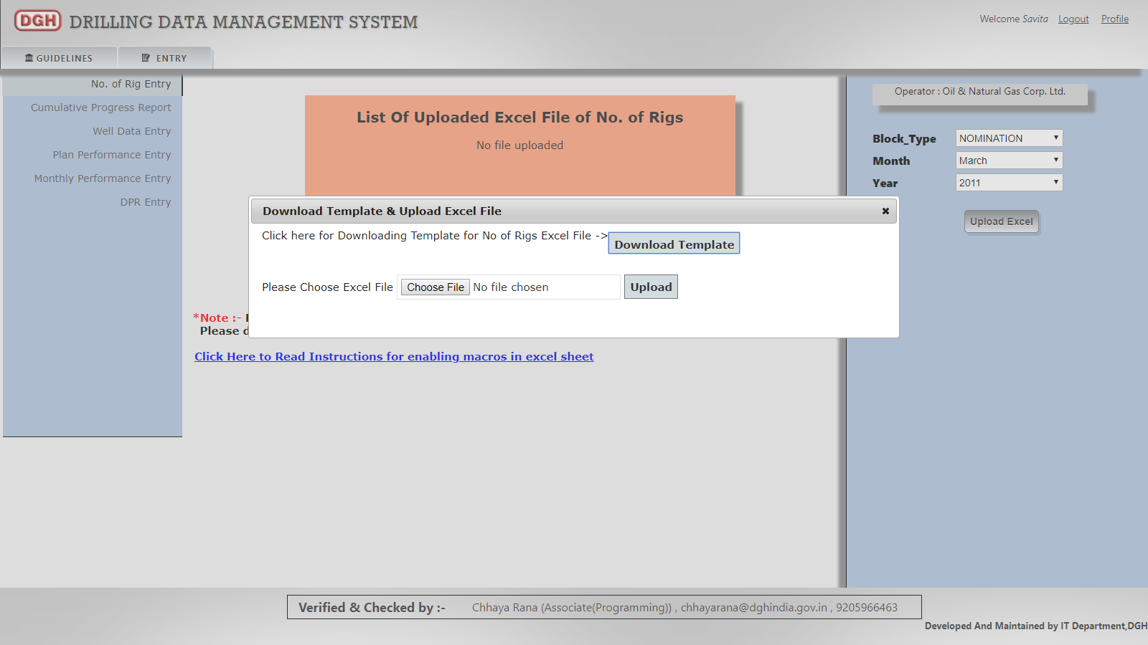

After uploading that excel, user can view their uploaded excel in “List of Uploaded Excel File”.
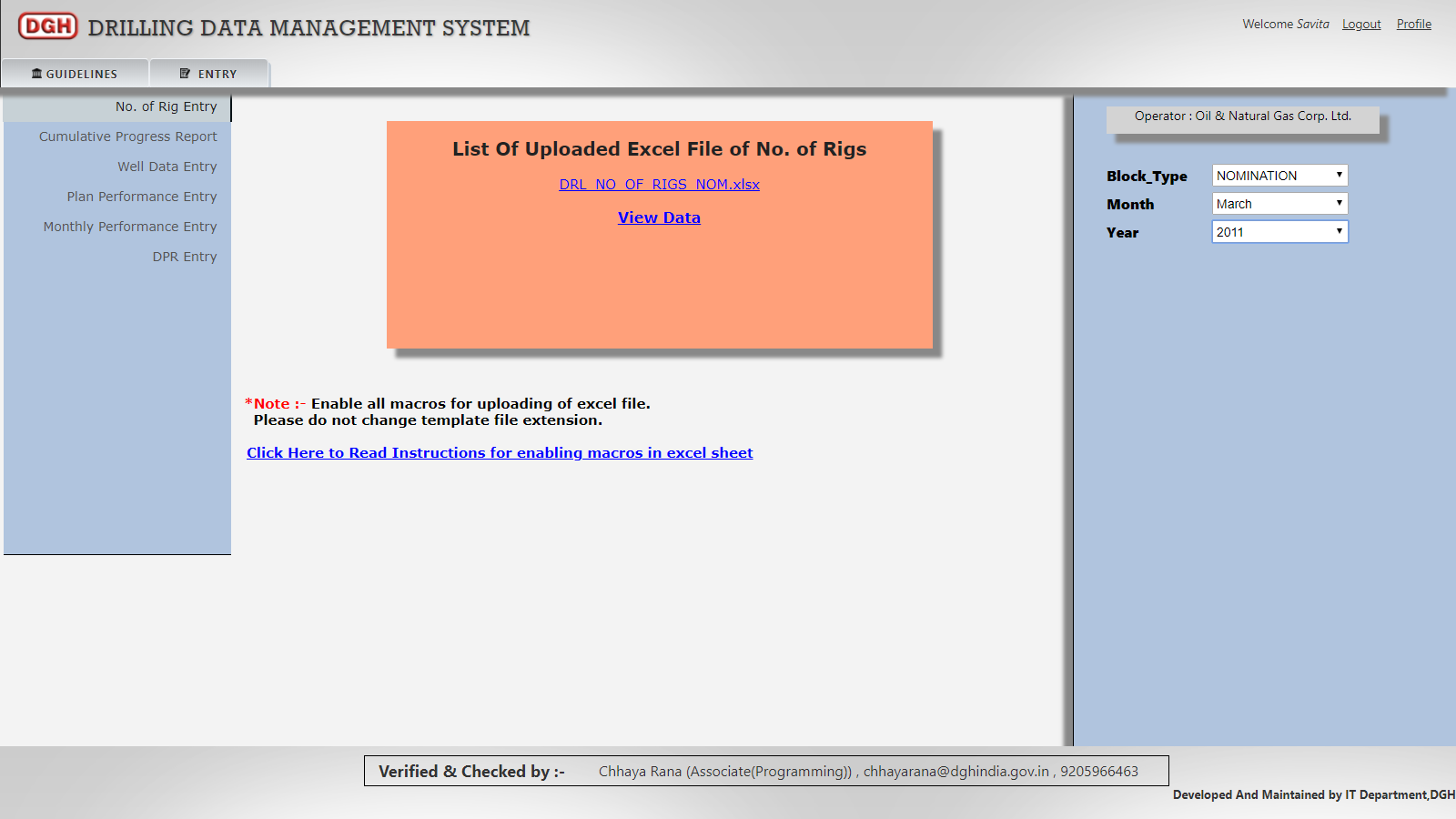
If user want to see their uploaded excel file, then user has to select respective Block Type, Month and Year. Then Uploaded excel file will be listed in “List of Uploaded Excel File”.

User can download excel file(which is uploaded by user) by clicking on particular file name.
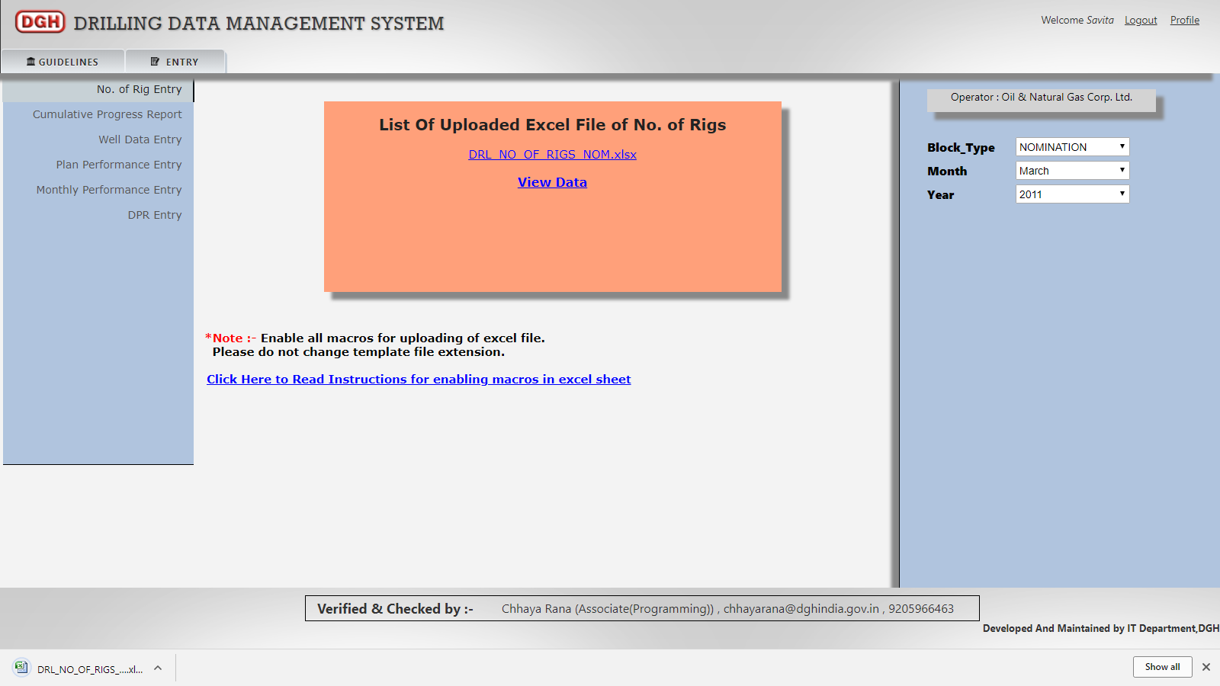

User can also view the data which he enter into the system by uploading the excel file by clicking on “View Data”.
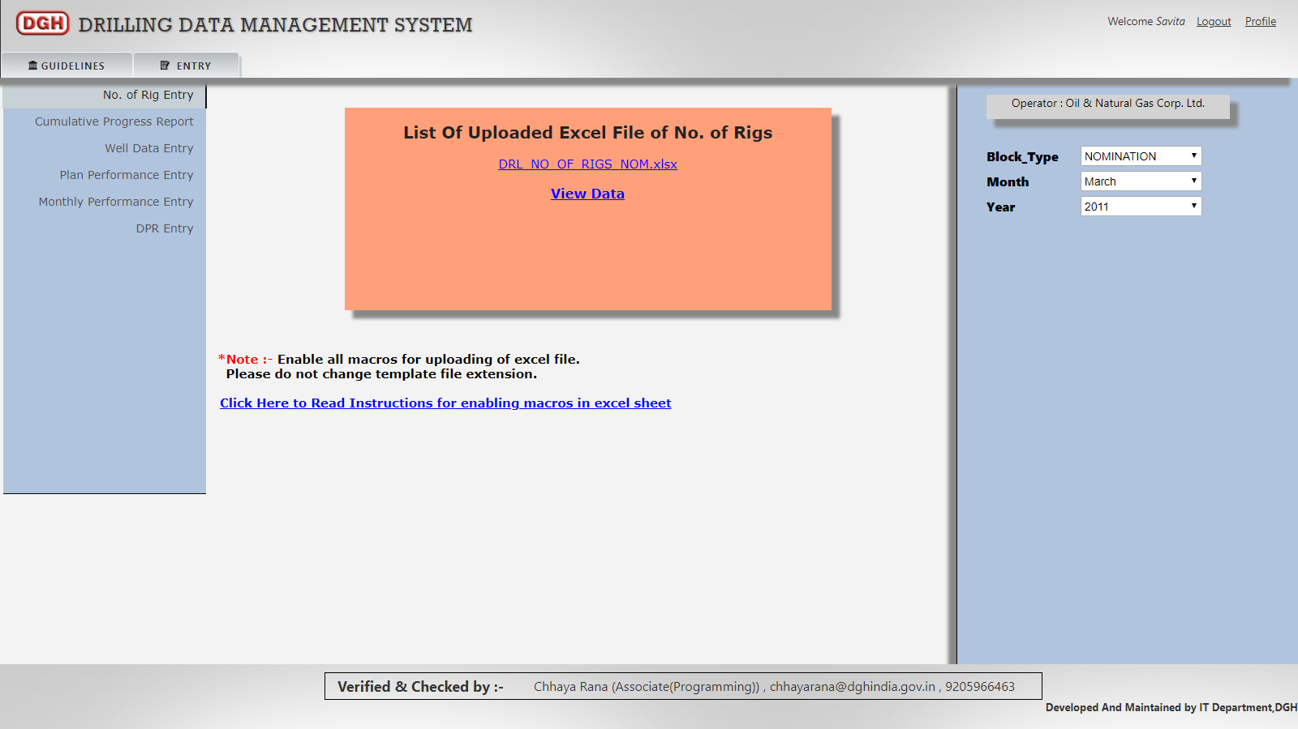

After clicking on “View Data” link user can view his submitted data.
